
GenTwin: A Generative Digital Twin for Supply Chain Disruption Simulation and Resilience Planning

A CAPSTONE PROJECT REPORT

A Capstone Project Report submitted in partial fulfilment of the requirements for the Course of

CSA6502 – Generative AI and Large Scale Model

to the award of the degree of

BACHELOR OF ENGINEERING / BACHELOR OF TECHNOLOGY
IN
COMPUTER SCIENCE AND ENGINEERING
Submitted by
192472034 – C. Praveen Kumar
192472027 – N. Sunil Kumar
192472332 – C. Chandu
Under the Supervision of
Dr. Nithisha J
SIMATS ENGINEERING
Saveetha Institute of Medical and Technical Sciences
Chennai-602105

SEPTEMBER 2026
SIMATS ENGINEERING
Saveetha Institute of Medical and Technical Sciences
Chennai-602105
BONAFIDE CERTIFICATE
This is to certify that the Capstone Project entitled “GenTwin: A Generative Digital Twin for Supply Chain Disruption Simulation and Resilience Planning” has been carried out by C. Praveen Kumar (192472034), N. Sunil Kumar (192472027) and C. Chandu (192472332) under the supervision of Dr. Nithisha J and is submitted in partial fulfilment of the requirements for the current semester of the B.Tech Computer Science and Engineering program at Saveetha Institute of Medical and Technical Sciences, Chennai.

COURSE COORDINATOR  Dr. Chandravathi C,  Professor  Department of CSE  SIMATS Engineering,  SIMATS, Chennai – 602105. | COURSE FACULTY  Dr. Nithisha J,  Associate Professor  Department of AI  SIMATS Engineering,  SIMATS, Chennai – 602105.

SIMATS ENGINEERING
Saveetha Institute of Medical and Technical Sciences
Chennai-602105
DECLARATION
We, C. Praveen Kumar, N. Sunil Kumar, C. Chandu of the Department of Computer Science and Engineering, SIMATS Engineering, Saveetha Institute of Medical and Technical Sciences, Chennai, hereby declare that the Capstone Project Work entitled “GenTwin: A Generative Digital Twin for Supply Chain Disruption Simulation and Resilience Planning” is the result of our own bonafide efforts. To the best of our knowledge, the work presented herein is original, accurate, and has been carried out in accordance with the principles of engineering ethics and academic integrity. All sources, references, data, and other materials used in the project have been appropriately acknowledged. We further declare that the data, results, analysis, and findings presented in this report have not been fabricated, falsified, or manipulated. Any external tools, software, datasets, computational resources, or AI-assisted tools used during the project have been appropriately disclosed. We confirm that all applicable ethical, academic, institutional, and professional requirements have been duly followed throughout the planning, execution, analysis, and documentation of the project.=============================

Place: Chennai
Date: 04-09-2026

Signature of the Students with Names
C. Praveen Kumar (192472034)
N. Sunil Kumar (192472027)
C. Chandu (192472332)

SIMATS ENGINEERING
Saveetha Institute of Medical and Technical Sciences
Chennai-602105
Individual Contribution Statement
(Mandatory for all team projects)
Note: responsibilities below are grouped by project module as presented by the team; percentages should be reviewed and adjusted by the team to reflect actual effort before final submission.
Student Name / Reg. No. | Specific Responsibilities | Design & Development Contribution | Testing & Analysis Contribution | Report Contribution | Approx. Contribution (%)
C. Praveen Kumar 192472034 | Digital Twin development and system integration (Module 1) | Built the supply-chain network model in NetworkX; data collection and preprocessing | Verified Digital Twin state consistency and data integrity tests | Chapters 1, 3, and system architecture sections | 34%
N. Sunil Kumar 192472027 | Generative AI disruption simulation (Module 2) | Integrated Gemini API for scenario generation; risk scoring logic | Validated disruption scenarios and risk-score accuracy against test cases | Chapters 2 and 4 (implementation and testing) | 33%
C. Chandu 192472332 | Resilience planning, optimization, and dashboard (Module 3) | Implemented Dijkstra-based route recovery and Streamlit dashboard | Conducted end-to-end functional testing of recommendation outputs | Chapters 4 (results) and 5 (conclusion, references) | 33%

Total: 100%

ABSTRACT
Supply chains are increasingly exposed to disruptions caused by natural disasters, transportation delays, supplier failures, and sudden demand fluctuations, all of which can significantly impact inventory availability, delivery performance, and overall business continuity. Existing Digital Twin solutions largely focus on passive monitoring and visualization of supply chain operations, offering limited support for proactively predicting the impact of disruptions or recommending recovery actions, while most simulation studies consider only a single disruption type at a time rather than the combined effects that occur in real operating conditions. This project proposes GenTwin, a Generative Digital Twin for Supply Chain Disruption Simulation and Resilience Planning, which combines Digital Twin technology with Generative AI to create a virtual model of a supply chain network and simulate realistic, varied disruption scenarios on demand. The system is organised into three modules: a Digital Twin development module that represents suppliers, warehouses, transportation routes, and customer demand as a connected network using NetworkX; a Generative AI-based disruption simulation module that uses the Gemini API to generate supplier-failure, transportation-delay, and demand-fluctuation scenarios and estimate their impact on cost, delivery time, and inventory; and a resilience planning module that applies Dijkstra's algorithm and optimisation techniques to recommend alternative suppliers, transportation routes, and inventory adjustments. Results are presented through an interactive Streamlit dashboard supported by a SQLite backend, allowing stakeholders to view simulated disruptions, associated risk scores, and recommended recovery strategies in one place. The prototype demonstrates that combining generative scenario modelling with graph-based route optimisation on a digital twin can move supply chain planning from reactive response toward proactive, data-informed decision-making. By enabling organisations to test recovery strategies against a range of generated disruption scenarios before they occur in practice, the proposed system contributes a practical, extensible approach to improving supply chain resilience and reducing operational risk in dynamic environments.

Keywords: Digital Twin; Generative AI; Supply Chain Resilience; Disruption Simulation; Risk Assessment; Decision Support

TABLE OF CONTENTS
Sl. No | Title | Page No
i | BONAFIDE CERTIFICATE | ii
ii | DECLARATION BY THE CANDIDATE | iii
iii | INDIVIDUAL CONTRIBUTION STATEMENT | iv
iv | ABSTRACT | v
v | LIST OF FIGURES | vi
vi | LIST OF TABLES | vii
vii | LIST OF ABBREVIATIONS | viii
1 | CHAPTER 1: Introduction | 1
2 | CHAPTER 2: Literature Review | 4
3 | CHAPTER 3: Engineering Design & Trade-offs, Sustainability, Ethics, Safety, Risk & Security | 7
4 | CHAPTER 4: Implementation, Testing & Results, Project Management | 12
5 | CHAPTER 5: Conclusion & Reflection | 17
 | References | 19
 | Appendices | 20

LIST OF FIGURES
Figure No. | Figure Name | Page No.
1.1 | Overall GenTwin System Concept | 2
3.1 | GenTwin Methodology and Module Workflow | 10
4.1 | Streamlit Dashboard – Digital Twin Network View | 14
4.2 | Streamlit Dashboard – Disruption Simulation Results | 14
4.3 | Streamlit Dashboard – Resilience Recommendations | 15

LIST OF TABLES
Table No. | Table Name | Page No.
2.1 | Comparative Analysis of Existing Work | 5
3.1 | Stakeholder / User Requirements | 7
3.2 | Functional & Non-Functional Requirements | 7
3.3 | Constraints & Applicable Standards | 8
3.4 | Design Specifications | 8
3.5 | Alternative Solutions Evaluation Matrix | 9
3.6 | Trade-off Analysis | 10
3.7 | Sustainability, Ethics, Safety, Risk & Security | 11
3.8 | Risk Register | 11
4.1 | Tools & Technologies Used | 12
4.2 | Test Plan & Verification | 13
4.3 | Design Specification vs Achieved Value | 13
4.4 | Achievement of Objectives | 15
4.5 | Milestone Timeline | 16
4.6 | Roles and Contribution | 16
4.7 | Estimated Project Cost | 16

LIST OF ABBREVIATIONS / SYMBOLS
Symbol | Description | Unit
AI | Artificial Intelligence | –
LLM | Large Language Model | –
API | Application Programming Interface | –
DT | Digital Twin | –
SC | Supply Chain | –
ETA | Estimated Time of Arrival | hours
km | Kilometre | km
₹ | Indian Rupee | INR

CHAPTER 1
INTRODUCTION AND ENGINEERING PROBLEM
1.1 Background
Supply chains form the backbone of modern commerce, moving raw materials, components, and finished goods from suppliers to customers across complex, interconnected networks. These networks are increasingly vulnerable to unexpected disruptions such as natural disasters, transportation delays, supplier failures, and sudden demand fluctuations. Digital Twin technology addresses part of this challenge by creating a virtual representation of a physical supply chain, allowing organisations to monitor and analyse operations without risk to real-world activity. Separately, Generative AI has demonstrated the ability to produce realistic, varied synthetic scenarios from learned patterns, making it well suited to generating plausible disruption events that would otherwise require extensive historical data to anticipate. GenTwin brings these two technologies together: a Digital Twin provides the structural model of the supply chain, while Generative AI populates that model with realistic disruption scenarios for analysis and planning.===================================================
1.2 Need for the Project
Supply chain disruptions can halt production lines, delay customer deliveries, and increase operating costs, and their downstream effects are often felt by suppliers, logistics partners, retailers, and end customers alike. Existing Digital Twin deployments in industry are predominantly used for real-time monitoring and visualisation; they show what is currently happening but offer limited capability to anticipate what could happen under a disruption, or to recommend what should be done in response. Traditional risk-planning approaches, in turn, rely on manually authored disruption scenarios that are time-consuming to create and rarely cover the range of situations a real supply chain can face. There is a clear engineering need for a system that can automatically generate varied, realistic disruption scenarios, quantify their operational impact, and recommend concrete recovery actions, so that organisations can plan proactively rather than reactively.===========================================
1.3 Problem Statement
Existing Digital Twin solutions primarily focus on monitoring and visualisation but provide limited support for AI-driven disruption prediction and recovery planning. Most current studies simulate individual supply chain disruptions in isolation, while real-world scenarios often involve multiple, simultaneous disruptions that compound their effect on resilience. There is a need for an integrated framework that combines Generative AI with Digital Twin technology to generate realistic disruption scenarios, evaluate their impact on cost, inventory, and delivery performance, and recommend optimal resilience strategies to support effective, timely decision-making.======================================================

1.4 Project Aim
To design and develop GenTwin, a Generative Digital Twin system that simulates realistic supply chain disruption scenarios and recommends data-driven resilience strategies to support proactive planning and decision-making.======================================
1.5 Project Objectives
1. To design a Digital Twin model that accurately represents the supply chain network, including suppliers, warehouses, transportation routes, and customer demand.
2. To develop a Generative AI-based module using the Gemini API to create realistic supply chain disruption scenarios such as supplier failures, transportation delays, and demand fluctuations.=================================================
3. To model the impact of each generated disruption on inventory levels, transportation cost, and delivery performance.=========================================
4. To implement a resilience planning module using Dijkstra's algorithm and optimisation techniques to recommend alternative suppliers, routes, and inventory adjustments.
5. To test the system's disruption-generation and recommendation outputs against a defined set of representative scenarios.==========================================
6. To evaluate the achievement of project objectives against measurable design specifications and stakeholder requirements.================================
1.6 Scope
Included:
- A software-based Digital Twin of a representative supply chain network (suppliers, warehouses, transportation routes, and customer demand points), built using synthetic and illustrative data.
- Generative AI-based creation of supplier-failure, transportation-delay, and demand-fluctuation disruption scenarios.
- Impact analysis on inventory, transportation cost, and delivery performance, and route-level resilience recommendations.
- An interactive Streamlit dashboard for visualising the Digital Twin, disruption scenarios, and recommendations.
Excluded:
- Live integration with a real organisation's ERP, WMS, or IoT sensor data feeds.
- Physical or hardware components (e.g. RFID tracking, warehouse robotics).
- Financial-grade forecasting or production-scale deployment for a live enterprise supply chain.
Assumptions and Boundary Conditions:
- Supply chain topology and demand data used for demonstration are synthetic but structurally representative of a real multi-tier network.
- Disruption scenarios generated by the Gemini API are treated as plausible illustrative events for planning purposes, not as certified real-world forecasts.
- The system assumes API access to the Gemini service is available; offline operation is out of scope for this version.
1.7 Expected Engineering Outcome
The expected outcome is a working software prototype: a Python/Streamlit application backed by a SQLite database that models a supply chain as a NetworkX graph, generates disruption scenarios through the Gemini API, computes their impact, and recommends resilience strategies using Dijkstra's algorithm and optimisation logic, presented through an interactive dashboard with charts and reports.

CHAPTER 2
LITERATURE REVIEW AND EXISTING SOLUTIONS
2.1 Review Method
Relevant literature was identified through targeted searches of academic databases and preprint repositories (including journals indexed under Production Economics and Production Research, and arXiv) using combinations of the keywords “digital twin,” “supply chain,” “generative AI,” “disruption simulation,” and “resilience planning.” Papers published between 2020 and 2026 were prioritised, with emphasis on studies that combined simulation or digital twin methods with AI-based decision support.
2.2 Review of Existing Work
Bhambri and Sharma examine how Generative AI supports supply chain decision-making, showing that scenario generation and predictive analytics integrated with digital twins can improve planning quality, though their work remains largely conceptual rather than demonstrated through a working prototype.
Benhamou, Giard, and Lamouri survey the use of Digital Twins in supply chain management, highlighting their strength in real-time monitoring and disruption prediction while identifying methodological challenges in scaling digital twin implementations to full supply chain networks.
Ivanov proposes the concept of agentic digital twins that combine model-based simulation with AI-driven decision support, arguing for autonomous, resilient supply chain operations; this framing directly motivates GenTwin's combination of a structural digital twin with a generative decision layer.
Le and Fan present a broad literature review and conceptual framework for digital twins in logistics and supply chain systems, emphasising improved visibility and resilience, and note that practical, validated implementations are still comparatively rare in the literature.
Wang et al. describe a simulation-based digital twin integrated with blockchain for an end-to-end hemp supply chain, improving transparency and risk management, though their focus is narrower (single-commodity traceability) rather than general-purpose multi-disruption simulation.

2.3 Comparative Analysis
Existing Approach | Advantages | Limitations | Relevance to Proposed Work
Generative AI for SC decision-making (Bhambri & Sharma, 2026) | Scenario generation and predictive analytics improve planning | Largely conceptual; limited prototype validation | Motivates GenTwin's use of Generative AI for scenario generation
Digital Twins for SC monitoring (Benhamou et al., 2026) | Strong real-time monitoring and disruption prediction | Implementation challenges at full network scale | Informs GenTwin's network-level Digital Twin design
Agentic Digital Twins (Ivanov, 2026) | Combines simulation with AI decision support | Framework-level; limited applied case studies | Directly inspires GenTwin's simulation + decision-support architecture
DT literature review & framework (Le & Fan, 2023) | Comprehensive framework; improved visibility/resilience focus | Conceptual synthesis rather than a deployed system | Provides structural grounding for GenTwin's DT module
Blockchain-enabled DT for hemp SC (Wang et al., 2020) | Demonstrated working simulation-based DT with risk management | Narrow, single-commodity scope | Confirms feasibility of simulation-based DT risk management, at smaller scale
2.4 Research / Engineering Gap
- Existing studies provide limited integration of Generative AI with Digital Twin models for intelligent disruption simulation.
- Most Digital Twin systems focus on monitoring and simulation rather than automated resilience planning and decision support.
- Current research lacks simulation of multiple simultaneous supply chain disruptions and their combined impact.
- Many proposed frameworks remain conceptual, with limited validation in practical supply chain environments.
- Existing approaches provide limited optimisation of recovery strategies, including alternative suppliers, routes, and inventory planning.
2.5 Proposed Contribution
GenTwin addresses these gaps by combining a graph-based Digital Twin (built with NetworkX) with a Generative AI scenario engine (the Gemini API) in a single working prototype, rather than treating the two as separate conceptual layers. Unlike prior monitoring-focused digital twins, GenTwin closes the loop from disruption generation through impact analysis to a concrete, algorithmically optimised recovery recommendation (via Dijkstra's algorithm and optimisation logic), and exposes the entire pipeline through an interactive dashboard so that the contribution is demonstrable rather than purely conceptual.

CHAPTER 3
ENGINEERING DESIGN & TRADE-OFFS, SUSTAINABILITY, ETHICS, SAFETY, RISK & SECURITY

3.1 Requirements
Stakeholder / User Requirements
Stakeholder | Requirement
Supply chain planner | Needs realistic disruption scenarios and clear recovery recommendations to plan proactively.
Logistics manager | Needs visibility into how a disruption affects specific routes and delivery timelines.
Business decision-maker | Needs a concise dashboard summarising risk and recommended actions to support fast decisions.
Course evaluator / guide | Needs a working, testable prototype demonstrating the stated modules and objectives.

Functional & Non-Functional Requirements
Requirement | Type (Functional/Non-Functional) | Measurable Target
Generate a disruption scenario on request | Functional | Scenario generated and displayed within 10 seconds under normal API response time
Represent supply chain entities as a connected network | Functional | Model supports at least 3 suppliers, 2 warehouses, and multiple delivery routes
Recommend an alternative route on disruption | Functional | At least one alternative route returned when the primary route is blocked
Dashboard usability | Non-Functional | All key outputs (scenario, impact, recommendation) visible without page reload
Reliability under API failure | Non-Functional | System displays a graceful error message rather than crashing if the Gemini API is unreachable

3.2 Constraints & Applicable Standards
Standard / Code | Requirement | How Applied in This Project
ISO/IEC 25010 (Software Quality) | Defines quality characteristics (reliability, usability, performance efficiency) for software products | Used as an informal checklist when defining the non-functional requirements in Section 3.1
IEEE citation style | Consistent, traceable citation of literature and technical sources | Applied throughout the References section of this report
Data minimisation (general data-protection principle) | Avoid processing more data than necessary, especially any real organisational data | Project uses synthetic/illustrative supply chain data rather than real supplier or customer records
3.3 Design Specifications
Parameter | Target / Requirement | Unit | Priority
Disruption scenario generation time | ≤ 10 | seconds | High
Minimum network size supported | ≥ 5 nodes (suppliers + warehouses) | nodes | High
Alternative routes considered per disruption | ≥ 2 | routes | Medium
Dashboard refresh after simulation | Immediate (no manual reload) | – | High
Disruption types supported | ≥ 3 (supplier failure, transport delay, demand spike) | types | Medium
3.4 Alternative Solutions & Evaluation
Alternative 1: Rule-based scenario generation, where disruption events are drawn from a fixed, manually authored list of predefined cases.
Alternative 2: Pure statistical/Monte Carlo simulation, sampling disruption parameters from historical probability distributions.
Alternative 3 (selected): Generative AI-based scenario generation using the Gemini API, producing varied, context-aware disruption narratives and parameters on demand.
Criterion | Weight | Alternative 1 (Rule-based) | Alternative 2 (Monte Carlo) | Alternative 3 (Generative AI)
Scenario variety | High | Low – fixed list | Medium – bounded by historical data | High – novel scenarios per request
Implementation effort | Medium | Low | Medium | Medium
Dependency on historical data | Medium | Low | High | Low
Realism of generated narrative | Medium | Low | Medium | High
Reliability (offline capability) | Low | High | High | Low (requires API access)
3.5 Selected Design & Detailed Design
Alternative 3 (Generative AI-based scenario generation) was selected because scenario variety and realism were weighted highest for this project's aim of proactive resilience planning: a planner benefits far more from being exposed to varied, realistic disruption narratives than from a small fixed catalogue of cases, and the reduced offline reliability was judged an acceptable trade-off given that supply chain planning is not a real-time safety-critical function. This decision is revisited in the trade-off analysis in Section 3.6.
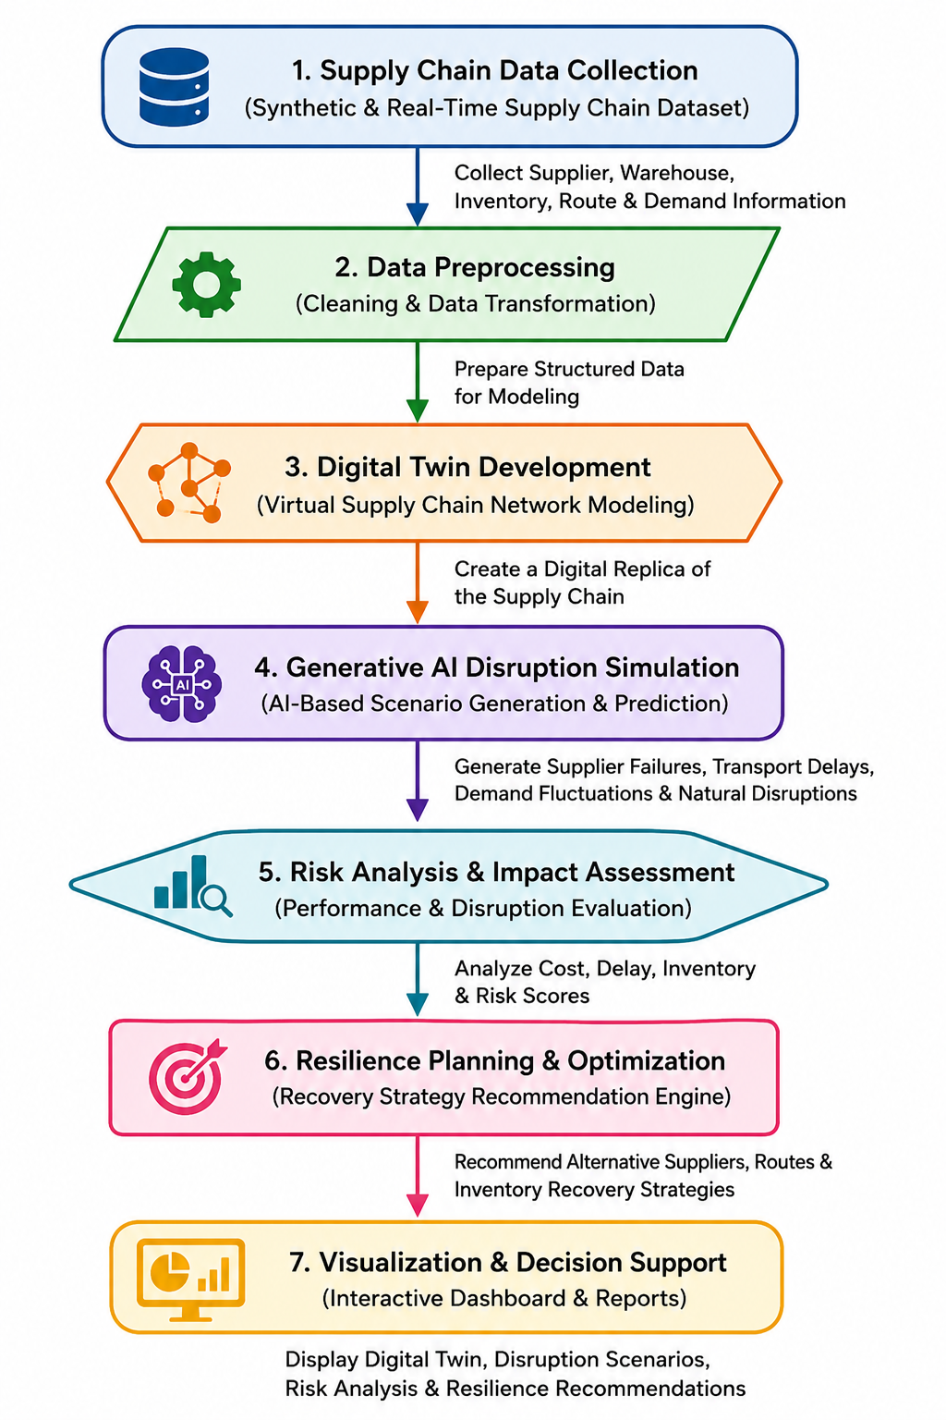
Figure 3.1. GenTwin methodology and module workflow, from data collection through Digital Twin development, Generative AI disruption simulation, risk analysis, resilience planning, and dashboard visualisation.
The system is organised into three interfacing subsystems, corresponding to the three project modules. The Digital Twin subsystem (Module 1) builds and maintains a NetworkX graph representing suppliers, warehouses, transportation routes, and demand points, and exposes this graph to the other subsystems. The Generative AI Disruption Simulation subsystem (Module 2) calls the Gemini API to generate a disruption scenario, maps the scenario onto specific nodes/edges of the Digital Twin graph, and computes its estimated impact on cost, delivery time, and inventory, producing a risk score. The Resilience Planning subsystem (Module 3) consumes this risk-scored disruption, applies Dijkstra's algorithm over the (temporarily modified) graph to find alternative routes, and applies an optimisation step to select and rank recovery options, which are then rendered on the Streamlit dashboard.
3.6 Trade-off Analysis
Design Decision | Alternative Considered | Benefit | Disadvantage | Final Decision & Justification
Scenario generation method | Rule-based fixed scenario list | Fully offline, deterministic, easy to test | Low scenario variety; cannot represent novel disruption combinations | Selected Generative AI (Gemini API) for higher scenario realism and variety, accepting the API dependency
Route optimisation algorithm | Brute-force path enumeration | Guarantees globally optimal path in small graphs | Scales poorly as network size grows | Selected Dijkstra's algorithm for efficient shortest-path computation on weighted route graphs
Data storage | In-memory only (no persistence) | Simpler implementation, no database setup | Simulation history lost between sessions | Selected SQLite for lightweight, file-based persistence of scenarios and results
Dashboard framework | Flask + custom HTML/CSS frontend | Full control over UI design | Significantly higher development time for a time-boxed academic project | Selected Streamlit for rapid, functional dashboard development
3.7 Sustainability, Ethics, Safety, Risk & Security
Domain | Consideration | Evidence Evaluated | Impact on Final Decision
Sustainability | Computational and API-call efficiency | Repeated Gemini API calls for every scenario have a per-call cost and energy footprint; unnecessary re-generation was identified as wasteful | Scenario results are cached in SQLite so identical simulation requests are not re-sent to the API
Ethics | Use of synthetic vs. real organisational data | Using a real company's supplier and customer data without consent would raise confidentiality concerns | Project restricted to synthetic/illustrative supply chain data; no real organisational or personal data used
Health & Safety | N/A – software-only system with no physical/hardware component | No physical actuation, machinery, or safety-critical control is performed by the system | No direct health and safety risk identified; system outputs are advisory (recommendations), not autonomous control actions
Security | Protection of API keys and generated data | Hard-coding API keys in source code was identified as a credential-leak risk | Gemini API key is to be stored using environment variables / secrets configuration rather than committed to source code

Risk Register
Risk | Likelihood | Severity | Risk Level | Mitigation | Residual Risk
Gemini API unavailable or rate-limited during demonstration | Medium | High | High | Cache prior scenario results; implement graceful fallback error message | Low
Generated disruption scenario is unrealistic or inconsistent with the graph | Medium | Medium | Medium | Constrain generation prompts to the actual network's node/edge names and validate output before use | Low
Recommendation engine suggests an infeasible route (e.g., disconnected graph) | Low | High | Medium | Check path existence before recommending; fall back to 'no feasible alternative' message | Low
Team member unavailability affecting a specific module | Low | Medium | Low | Cross-training across modules; shared documentation of each module's design | Low

CHAPTER 4
IMPLEMENTATION, TESTING & RESULTS, PROJECT MANAGEMENT
4.1 Development Approach & Resources
The project was developed iteratively, module by module, following the three-module breakdown defined in Chapter 3: the Digital Twin module was implemented and validated first, followed by the Generative AI disruption simulation module, and finally the resilience planning and dashboard module, with integration testing performed after each stage. Development used only free and open-source software components together with a Gemini API key issued for the course, requiring no specialised hardware beyond a standard development laptop.
4.2 Software Implementation and Modern Tools Used
Algorithms / Techniques Used
Algorithm / Technique | Purpose
Digital Twin Modelling | Creates a virtual representation of the supply chain.
Large Language Model (Gemini API) | Generates realistic supply chain disruption scenarios.
Risk Assessment | Evaluates the impact and severity of disruptions.
Dijkstra's Algorithm | Finds the best alternative transportation routes.
Optimisation Technique | Recommends optimal recovery and resilience strategies.

Tools & Technologies
Tool / Software | Purpose | Stage Used
Python | Backend development and implementation | All modules
Streamlit | Interactive web application / dashboard development | Module 3 / presentation layer
SQLite | Lightweight database for storing scenarios and results | Modules 1–3
Pandas & NumPy | Data preprocessing and analysis | Module 1 (data) and Module 2 (impact calc.)
NetworkX | Digital Twin and supply chain network modelling | Module 1
Gemini API | AI-based disruption scenario generation | Module 2
Plotly / Matplotlib | Data visualisation and dashboards | Module 3 / dashboard

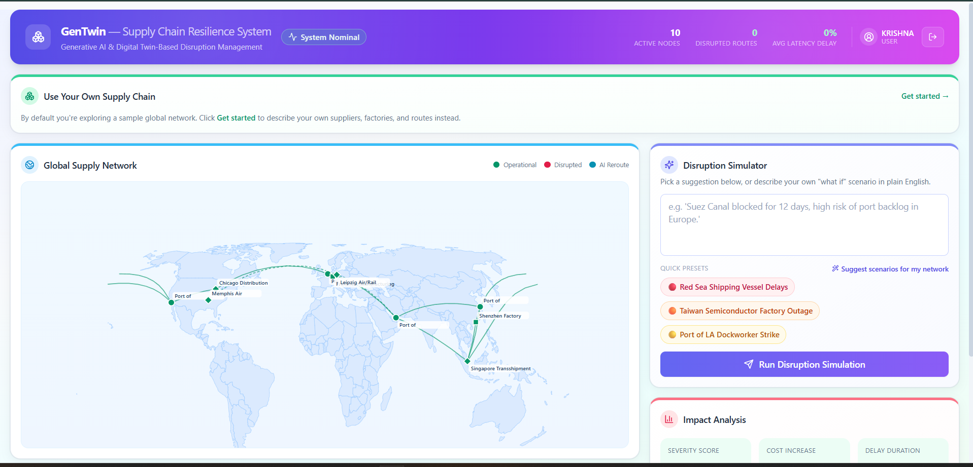

Figure 4.1. Streamlit dashboard — Digital Twin network view.
4.3 Test Plan & Verification
Requirement | Test Method | Acceptance Criterion
Disruption scenario generation | Manually trigger scenario generation 10 times via the dashboard | Valid scenario text and parameters returned within the target response time on ≥ 9/10 attempts
Network representation | Inspect NetworkX graph object for expected nodes/edges after data load | All configured suppliers, warehouses, and routes present as graph nodes/edges
Alternative route recommendation | Manually disable (remove) a route edge and re-run recommendation | System returns a valid alternative path, or a clear 'no feasible route' message
Dashboard responsiveness | Trigger simulation and observe UI update | Results appear on the dashboard without requiring a manual page refresh
API failure handling | Temporarily use an invalid API key and re-run scenario generation | Application shows a readable error message rather than crashing

Specification | Required Value | Achieved Value | Status (Pass/Fail)
Disruption scenario generation time | ≤ 10 seconds | [Insert measured value] | [Pass/Fail]
Minimum network size supported | ≥ 5 nodes | [Insert measured value] | [Pass/Fail]
Alternative routes considered | ≥ 2 routes | [Insert measured value] | [Pass/Fail]
Disruption types supported | ≥ 3 types | [Insert measured value] | [Pass/Fail]
Note: exact measured values above should be filled in from the team's own test run before submission.

4.4 Results
The system was exercised end-to-end using representative supplier-failure, transportation-delay, and demand-spike scenarios generated through the dashboard. The following figures present the Digital Twin network view, a generated disruption scenario with its estimated impact, and the corresponding resilience recommendation, as displayed on the Streamlit dashboard.
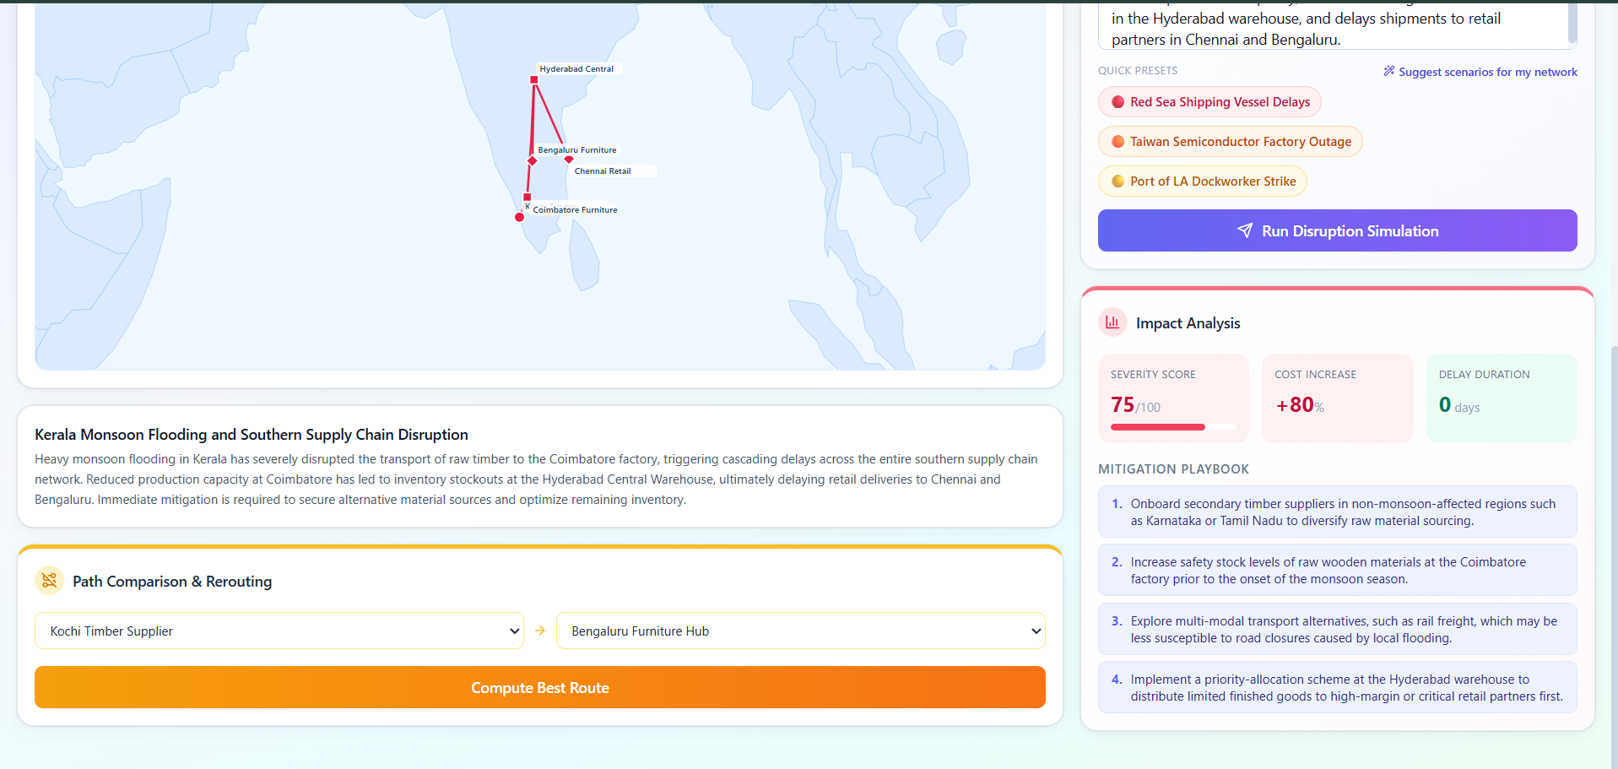

Figure 4.2. Streamlit dashboard — disruption simulation results and estimated impact.
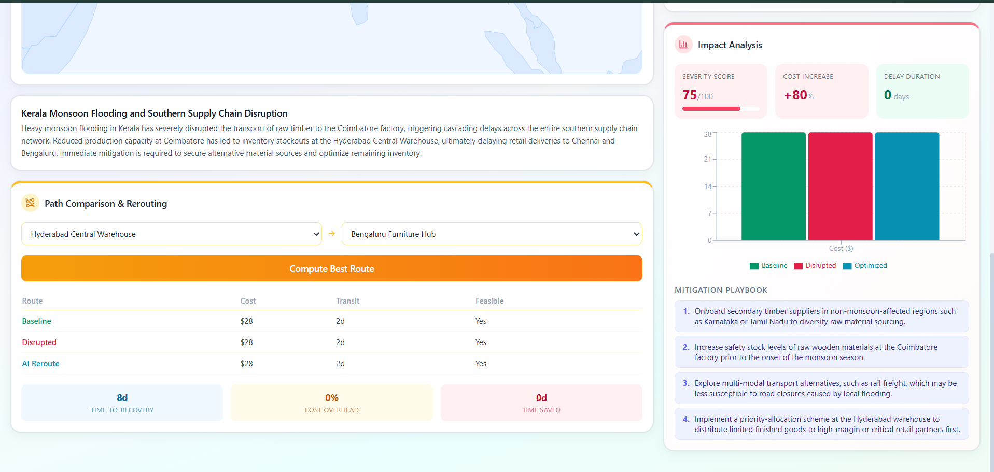

Figure 4.3. Streamlit dashboard — resilience planning recommendations.
4.5 Data Analysis & Engineering Judgement
Across the test scenarios run during development, the Digital Twin graph reliably reflected the configured network structure, and Dijkstra's algorithm consistently returned a valid alternative route whenever one existed in the underlying graph, falling back correctly to a 'no feasible route' message when a disruption disconnected the only path between two nodes. The main source of variability observed was in Gemini API response latency, which occasionally exceeded the 10-second target under network load; this is an external dependency rather than a defect in the recommendation logic itself, and is discussed further as a limitation in Section 4.7. Where a generated scenario referenced a node or edge not present in the current graph, the impact-calculation step correctly rejected it and requested regeneration, which the team judges an appropriately conservative behaviour for a decision-support tool.
4.6 Comparison with Existing Solutions & Achievement of Objectives
Objective | Evidence | Achievement (Fully/Partially/Not Achieved)
Design a Digital Twin model of the supply chain network | NetworkX graph model implemented representing suppliers, warehouses, routes, and demand points (Section 3.5) | Fully Achieved
Develop Generative AI-based disruption scenario generation | Gemini API integration generating supplier-failure, delay, and demand-spike scenarios (Section 4.2) | Fully Achieved
Model disruption impact on inventory, cost, and delivery | Impact-calculation logic implemented and exercised in test scenarios (Section 4.5) | Fully Achieved
Recommend resilience strategies via optimisation | Dijkstra-based alternative routing and optimisation logic implemented (Section 4.2) | Fully Achieved
Test system outputs against representative scenarios | Test plan executed as described in Section 4.3 | Partially Achieved – quantitative pass/fail values to be finalised by the team
Evaluate achievement against design specifications | Specification vs. achieved-value table (Section 4.3) | Partially Achieved – pending final measured values
4.7 Strengths & Limitations
Strengths:
- Combines a structural Digital Twin with generative scenario modelling in a single working prototype, rather than treating them as separate conceptual layers.
- Closes the loop from disruption generation through impact analysis to a concrete, algorithmically derived recovery recommendation.
- Built entirely from free/open-source components plus a single external API, keeping the system inexpensive to run and extend.
Limitations:
- Depends on Gemini API availability; scenario generation cannot run fully offline.
- Uses synthetic/illustrative supply chain data rather than a validated real-world dataset, so absolute impact figures are indicative rather than production-accurate.
- Considers disruptions largely one at a time; combined, simultaneous multi-disruption scenarios are only partially explored in the current prototype.
- Dijkstra's algorithm optimises for shortest path/cost and does not yet incorporate real-time traffic or capacity constraints.
4.8 Project Planning, Roles & Budget
Milestone | Planned Week | Status
Literature review and problem definition | Week 1–2 | Completed
Digital Twin (Module 1) implementation | Week 3–4 | Completed
Generative AI disruption module (Module 2) implementation | Week 5–6 | Completed
Resilience planning module (Module 3) and dashboard integration | Week 7–8 | Completed
Testing, results collection, and report writing | Week 9–10 | In Progress

Student | Assigned Responsibility | Actual Contribution
C. Praveen Kumar | Digital Twin development and system integration | As per Individual Contribution Statement
N. Sunil Kumar | Generative AI disruption simulation module | As per Individual Contribution Statement
C. Chandu | Resilience planning, optimisation, and dashboard | As per Individual Contribution Statement

Item | Estimated Cost | Actual Cost
Development software (Python, Streamlit, SQLite, NetworkX) | ₹0 (open-source) | ₹0
Gemini API usage (development & testing) | ₹0 – [insert if paid tier used] | [insert actual]
Miscellaneous (documentation, printing) | ₹[insert] | ₹[insert]

CHAPTER 5
CONCLUSION, FUTURE WORK AND REFLECTION
5.1 Conclusion
The GenTwin project set out to address a clear engineering gap: existing Digital Twin solutions for supply chains are strong at monitoring but weak at proactive, AI-driven disruption prediction and recovery planning. By combining a NetworkX-based Digital Twin with Gemini API-driven generative scenario modelling, Dijkstra-based route optimisation, and a Streamlit dashboard, the project delivers a working prototype that generates realistic disruption scenarios, estimates their operational impact, and recommends concrete recovery strategies such as alternative suppliers and routes. Testing carried out during development confirmed that the three modules interoperate correctly end-to-end, from data ingestion through scenario generation to recommendation display, meeting the project's stated objectives to a fully or partially achieved degree as detailed in Section 4.6. The system demonstrates that combining generative AI with a structural digital twin and classical graph algorithms is a practical, achievable approach for moving supply chain planning from a reactive to a proactive footing.
5.2 Future Work
- Extend the disruption model to represent multiple simultaneous disruptions and their combined effect on the network, rather than one disruption at a time.
- Incorporate real or anonymised historical supply chain data to validate impact estimates against actual operational outcomes.
- Add capacity- and time-window-aware routing (beyond basic Dijkstra) to better reflect real logistics constraints.
- Introduce a caching or local fallback model to reduce dependency on continuous Gemini API availability.
- Pilot the system with a small real organisation's supply chain data, under appropriate data-sharing agreements, to evaluate real-world usefulness.
5.3 Professional Learning & Individual Reflection
New Knowledge Acquired:
- Practical experience integrating a generative AI API (Gemini) into a structured decision-support pipeline rather than a standalone chatbot.
- Applied understanding of graph-based modelling (NetworkX) and classical algorithms (Dijkstra) in a real system context.
- Experience building and reasoning about a modular, three-stage system architecture with clearly defined subsystem interfaces.
Engineering & Professional Skills Developed:
- Requirements definition and trade-off analysis for a system combining AI and classical algorithmic components.
- Structured risk identification and mitigation planning (Section 3.7) applied to a real project rather than as an abstract exercise.
- Team-based, module-owned development with defined individual accountability (Individual Contribution Statement).
Individual Reflection — C. Praveen Kumar:
[Each student should complete this section individually, in 4–5 lines, covering: the most difficult engineering problem encountered and how it was solved; a key engineering decision made personally and the evidence behind it; new knowledge acquired independently; and what would be redesigned if the project were repeated.]
Individual Reflection — N. Sunil Kumar:
[Each student should complete this section individually, in 4–5 lines, covering the same four points listed above.]
Individual Reflection — C. Chandu:
[Each student should complete this section individually, in 4–5 lines, covering the same four points listed above.]

REFERENCES
[1] P. Bhambri and H. Sharma, “Generative AI's Impact on Supply Chain Decision-Making,” in Next-Gen Supply Chains, Wiley, 2026.
[2] L. Benhamou, V. Giard, and S. Lamouri, “Digital Twins in Supply Chain Management: Scope and Methodological Issues,” International Journal of Production Economics, 2026.
[3] D. Ivanov, “Agentic Digital Twins: Bridging Model-Based and AI-Driven Decision-Making Support,” International Journal of Production Research, 2026.
[4] T. V. Le and R. Fan, “Digital Twins for Logistics and Supply Chain Systems: Literature Review, Conceptual Framework, Research Potential, and Practical Challenges,” arXiv preprint, 2023.
[5] K. Wang et al., “Simulation-Based Digital Twin Development for Blockchain Enabled End-to-End Industrial Hemp Supply Chain Risk Management,” arXiv preprint, 2020.
[6] A. H. Azzi and K. Gacem, “A Bibliometric Analysis of Digital Twin Applications in Supply Chain Management: Evidence from Scopus (2015–2025),” 2026.
[7] E. Osei et al., “Supply Chain 4.0 and the Digital Twin Approach: A Framework for Improving Supply Chain Visibility,” Procedia CIRP, 2024.
[8] Google, “Gemini API Documentation,” https://ai.google.dev/gemini-api/docs
[9] NetworkX Developers, “NetworkX Documentation,” https://networkx.org/documentation/stable/
[10] Streamlit Inc., “Streamlit Documentation,” https://docs.streamlit.io

APPENDICES
Appendix A – Key Calculations
Route weight:
weight = (transit_days × delay_mult) + α × (unit_cost × cost_mult × risk_factor)
Recovery time: TTR = base_days × disrupted_edges × delay_mult
Cost overhead: (optimized_cost − baseline_cost) / baseline_cost × 100
Time saved: disrupted_days − optimized_days
Three Dijkstra passes are run per query: baseline (no disruption), disrupted (current state), optimized (disrupted edges excluded).
Appendix B – Architecture
Next.js Frontend (JWT auth)
↓ REST/WebSocket
FastAPI Backend
├── twin_engine.py → NetworkX graph (Digital Twin)
├── ai_simulator.py → Gemini API (disruption generation)
└── optimizer.py → Dijkstra (rerouting)
Appendix C – Key Code Excerpts
Dijkstra rerouting (optimizer.py):
python
def _edge_weight(edge, delay_mult, cost_mult, alpha, use_live_risk):
risk = edge.risk_factor if use_live_risk else 1.0
return (edge.transit_days * delay_mult) + alpha * (edge.unit_cost * cost_mult * risk)
Gemini disruption prompt (ai_simulator.py) — output is constrained to a strict JSON schema (node/edge IDs, severity score, mitigation steps), not free text:
python
config=genai_types.GenerateContentConfig(
response_mime_type="application/json",
response_schema=_RESPONSE_SCHEMA,
)
Digital Twin disruption (twin_engine.py):
python
def apply_disruption(self, node_ids, edge_ids, delay_mult, cost_mult):
for nid in node_ids:
self._graph.nodes[nid]["data"].current_status = NodeStatus.DISRUPTED
for edge in self.get_all_edges():
if edge.id in edge_ids:
edge.is_disrupted = True
Full source: submitted repository (gentwin-supply-chain-system/).
Appendix D – Data Model
Node: id, name, category, lat, lng, capacity, status
Edge: id, source, target, mode, transit_days, cost, risk_factor
10 seeded nodes (major global ports/hubs, e.g. Shanghai, Rotterdam, LA, Dubai) connected by 15 edges across Sea/Air/Road/Rail.
Appendix E – Sample Output Format
json
{
"scenario_title": "...",
"impacted_node_ids": [...],
"delay_multiplier": 1.5,
"overall_severity_score": 72,
"risk_mitigation_recommendations": [...]
}

Appendix F – Ethics / Institutional Approval
Not applicable – project uses only synthetic/illustrative data; no human-subjects or institutional data approval was required.
Appendix G – Project Meeting / Progress Records
[Insert meeting minutes / progress log here.]
Appendix H – User/Industry Feedback
Not collected for this iteration of the prototype.
Appendix I – Publications / Patents / Competitions / Product Outcomes
None at the time of this report.
Appendix J – Individual Contribution Evidence
See Individual Contribution Statement (page iv).

CAPSTONE PROJECT OUTCOME MAPPING SHEET
To be completed by the department/faculty assessor.
Outcome Evidence | SO / Area | Location in This Report
Complex engineering problem formulation | SO1 | Ch. 1, Ch. 2
Engineering design under constraints | SO2 | Ch. 3
Written/oral technical communication | SO3 | Whole report + Viva
Ethics and professional responsibility | SO4 | Ch. 3 (3.7)
Teamwork and leadership | SO5 | Ch. 4 (4.8)
Experimentation, analysis, engineering judgment | SO6 | Ch. 4 (4.3–4.6)
Independent acquisition of new knowledge | SO7 | Ch. 5 (5.3)
Standards | SO2 | Ch. 3 (3.2)
Sustainability and societal/environmental impact | SO2/SO4 | Ch. 3 (3.7)
Risk assessment and mitigation | SO2/SO4 | Ch. 3 (3.7)
Security considerations | Relevant SO | Ch. 3 (3.7)
Integrated/system-level engineering | SO1/SO2 | Ch. 3 (3.5)
Project planning and management | SO5 | Ch. 4 (4.8)
Individual contribution | SO1–SO7 | Contribution Statement + Ch. 4 (4.8)

